Practical No 1
1.Singly linked list
CODE:
# a single node of a singly linked list
class Node:
#constructer
def __init__ (self,data = None,next=None):
self.data = data
self.next = next

# A LINKED LIST CLASS WITH A SINGLE HEAD NODE
class LinkedList:
def __init__ (self):
self.head = None

# INSERTION METHOD FOR THE LINKED LIST
def insert(self,data):
newNode = Node(data)
if(self.head):
current = self.head
while( current.next):
current = current.next
current.next = newNode
else:
self.head = newNode

# PRINT METHOD FOR LINKED LIST

def printLL(self):
current = self.head
while(current):
print( current.data)
current = current.next

# SINGLY LINKED LIST WITH INSERTION AND PRINT METHODS

LL = LinkedList()
LL.insert(3)
LL.insert(4)
LL.insert(5)
LL.printLL()
OUTPUT:
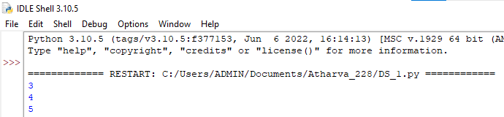

Practical No 2
Doubly linked list
CODE:
class Node:
def __init__ (self,my_data):
self.perv = None
self.data = my_data
self.next = None
class double_list:
def __init__ (self):
self.head = None
self.tail = None
def add_data(self,my_data):
new_node = Node(my_data)
if(self.head == None):
self.head = self.tail = new_node;
self.head.previous = None;
self.tail.next = None;
else:
self.tail.next = new_node;
new_node.previous = self.tail;
self.tail = new_node;
self.tail.next = None;
def print_it(self):
curr = self.head
if (self.head == None):
print("The list is empty")
return
print("The node is in the doubly linked list")
while curr !=None:
print(curr.data)
curr = curr.next
my_instance = double_list()
print("Elements are being added to the doubly linked list")
my_instance.add_data(10)
my_instance.add_data(24)
my_instance.add_data(54)
my_instance.add_data(77)
my_instance.add_data(92)
my_instance.print_it()

OUTPUT:
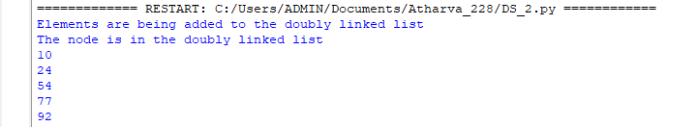
Practical No 3
Stack
CODE:
class Stack:
def __init__ (self):
self.stack = []

def add (self,dataval):
if dataval not in self.stack:
self.stack.append(dataval)
return True
else:
return False

def peek (self):
return self.stack[-1]
AStack = Stack ()
AStack.add("MONDAY")
AStack.add("TUESDAY")
AStack.peek()
print(AStack.peek())
AStack.add("WEDNESDAY")
AStack.add("THURSDAY")
print(AStack.peek())

OUTPUT:
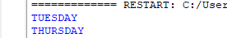

2. Pop stack
CODE:
class Stack:
def __init__ (self):
self.stack = []

def add (self,dataval):
if dataval not in self.stack:
self.stack.append(dataval)
return True
else:
return False

def peek (self):
return self.stack[-1]
AStack = Stack ()
AStack.add("MONDAY")
AStack.add("TUESDAY")
AStack.peek()
print(AStack.peek())
AStack.add("WEDNESDAY")
AStack.add("THURSDAY")
print(AStack.peek())

OUTPUT:
